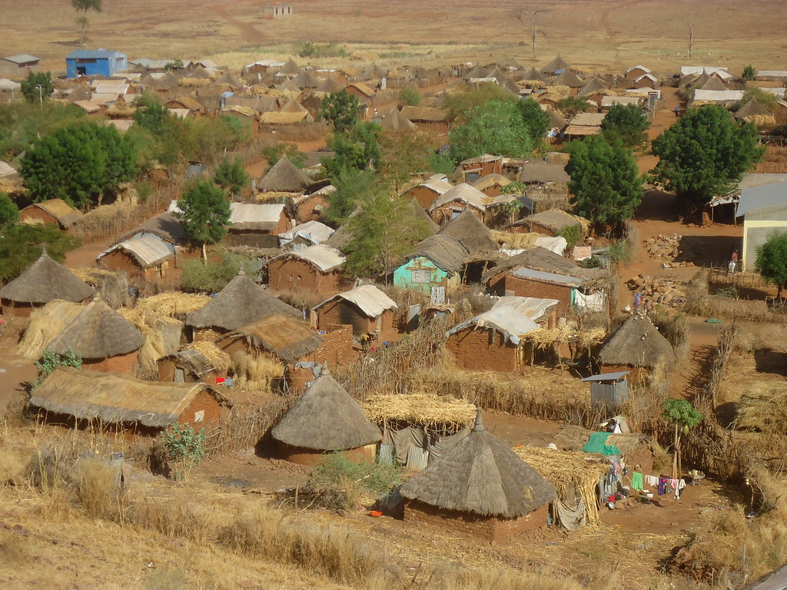
Housing, Land and Property rights
Access to land in Sudan

Access to land in Sudan

INFORMATION SHEET ON

The Norwegian Refugee Council (NRC) is an independent humanitarian organization helping people forced to flee. We work in crises across 31 countries, providing life-saving and long-term assistance to millions of people every year.
NRC works to protect the rights of displaced and vulnerable persons during crisis. In Sudan, NRC is implementing programmes under the Water sanitation and hygiene, Food security and Livelihoods, Education, Shelter and settlement, Camp coordination & camp management, Information counselling & Legal Assistance areas of competence.
Information, Counselling & Legal Assistance (ICLA) is a legal aid programme seeking to assist displaced persons to claim and fulfil their rights through application of information, counselling and legal assistance services.
In Sudan NRC ICLA conducts activities on Housing Land and Property (HLP) issues, Civil and Identity Documentation and Employment laws and procedures.
THE NORWEGIAN REFUGEE COUNCIL
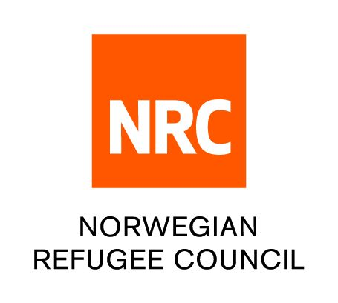
All information provided in this document is intended as a general guide only and is not a substitute for seeking advice from a qualified lawyer and/or government authorities. The information in this leaflet is subject to change and individuals should ensure that they obtain up to date information

Access to land generally refers to the ability to use land and other natural resources, to control the resources and to transfer the rights to the land.
- Article 61 of the 2019 Constitution enshrines the right to land ownership in Sudan. It provides that every citizen has the right to acquire and own property in accordance with the law.
- The rights of access to land are governed through land tenure systems.
- There are several ways to gain access to land;
- Purchase
- leasing or renting
- sharecropping or gaining access to land in return for paying the owner a percentage of the output
- emergency housing and informal settlements
- belonging to a particular group, especially in those cases where States recognize customary tenure as a legitimate tenure system

There are two parallel systems of land rights exist in Sudan;
- Statutory land tenure – Where State legislation and institutions govern land and natural resource rights within national boundaries
- Customary/Traditional land tenure - HLP rights are governed through a set of rules accepted in particular community overtime and administered by community leaders (These are usually not written)

The statutory system in Sudan recognizes three types of land tenure:
- Registered freehold,
- Registered leasehold
- “Hiyaza” or possessional tenure
Examples of land rights for Sudanese citizens
- Right to use the land
- Right to exclude other people from using the land
- Right to control how land will be used
- Right to derive income from the land
- Right to protection from illegal expropriation of the land
- Rights to transfer land to one’s successors
- A right to rent the land for investment (e.g cultivation, Bricks making)
Traditional authorities/customary institutions
- Local elders or the chiefs exercise administrative control and handle land disputes.
- Individuals with complaints over land issues are expected to take their complaints to them.
- Within the country, local and regional religious courts handle family matters and are staffed with customary authorities. These courts constitute an integral part of the judiciary system.

- Article 559 of the Civil Transaction Act 1984 gives the government ownership of all unregistered lands in Sudan on the premise that the government is the caretaker of lands on behalf of God, the rightful owner of all lands
- Articles 560 & 560(4) also recognize customary tenure and ownership of land

THE DIGITAL COMMUNITY HUB
- Call NRC for free on 015 655 9807
- Information available in English, Arabic, Tigrinya and Amharic (from 8:00 AM to 4:00 PM every day).
- If you are a Refugee or Internally Displaced Person in Khartoum, get information on obtaining legal documents and on our Cash for Food Programme.
- The call will not cost you anything.
- You can also leave us a message with your complaint or feedback on our services and we wll get back to you (Sunday - Thursday, between 8:00 AM and 4:00 PM)
www.nrc.no

